**Assignment**

Question 1.

Write a function to determine winner in a game of teen patti.(In any language / framework of your choice)

[Rules of teenpatti](http://teenpatti.octro.com/learn-teen-patti/index.html)

Input: Array of players. Each player has three cards. A card is denoted by an integer.

Sample Input: [ [ 12, 23, 45 ], [ 0, 32, 50 ], [ 25, 6, 17 ], [ 22, 33, 44 ], [ 43, 49, 16 ] ]

Output: Index of winning player

Cards Integer assignment is done as per image below:

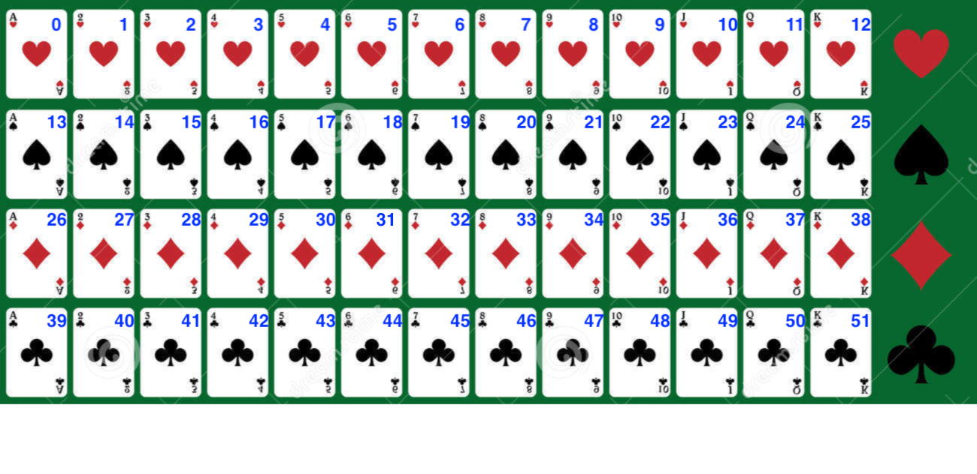

Question 2:

You work as a manager for a chip manufacturer, and you currently have 3 people on the road meeting clients. Your salespeople are in Jaipur, Pune and Bangalore, and you want them to fly to three other cities: Delhi, Mumbai and Kerala. The table below shows the cost of airline tickets in INR between the cities:

[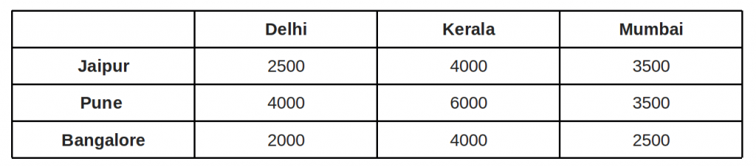](https://www.geeksforgeeks.org/wp-content/uploads/hungarian1.png)

Write an function to find where would you send each of your salespeople in order to minimize fair?

Try to keep minimum time complexity for your answers. Good Luck !!